Stretching

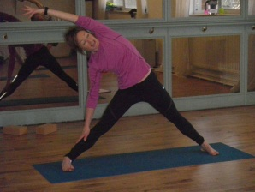
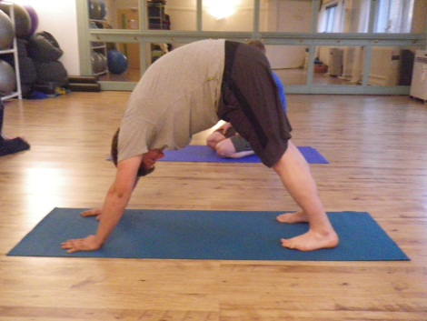
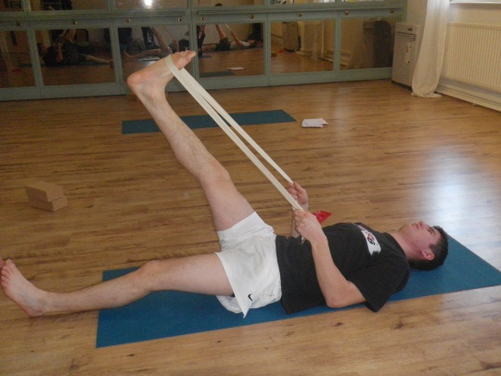

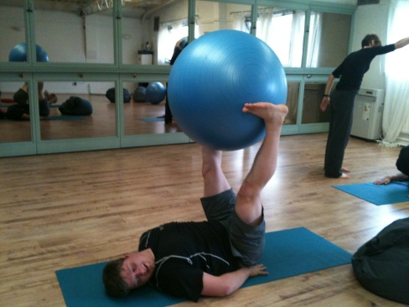

Some rules and advice:

- Never stretch into sharp or burning pain.
- There should be a tight feeling at the end of the stretch.
- Ease into the stretches gently and take the stretch a bit further each time.
- Don’t bounce, ease into the movement
- Hold each stretch for a least 10 seconds.
- Do the stretches that feel good and suitable for you.

